**Emory Genetics Lab Blog**

[EGL is a Proud Supporter of Decode Duchenne, Jain Foundation, and the LGMD Consortium](http://blog.geneticslab.emory.edu/egl-partners-with-the-decode-duchenne-project-jane-foundation)

Posted by Antonio Shaw on December 10, 2016

Muscular dystrophy (MD) is a group of musculoskeletal diseases that cause progressive weakness, loss of muscle mass, and impaired locomotion. In muscular dystrophy, abnormal genetic variations impede the production of proteins necessary for healthy muscles. There are various types of MD, and the clinical presentations of the most common variety begin in childhood, primarily in males. However, other types of MD don't appear until adulthood.

With many of the neuromuscular disorders overlapping in their clinical and/or pathological phenotypes, molecular testing can be necessary to pinpoint the precise disorder a patient has.

EGL has partnered with three organizations, [Parent Project Muscular Dystrophy](http://www.parentprojectmd.org/), the [Jain Foundation](http://www.jain-foundation.org/), and [LGMD consortium](http://lgmd-diagnosis.org/about-the-sponsors) to help spread MD awareness, provide assistance to individuals and families affected by MD, and find a cure.

PPMD_DecodeDuchenneLogoRGB-LockupHorizontal.jpg

[Decode Duchenne](https://www.duchenneconnect.org/component/content/article.html?id=780) is a free genetic testing and counseling program administered by Parent Project Muscular Dystrophy. Eligible patients must have a confirmed or suspected diagnosis of Duchenne muscular dystrophy (DMD) or Becker muscular dystrophy (BMD). Decode Duchenne helps overcome the financial barriers involved in accessing genetic testing and counseling.

The Jain Foundation is a privately funded non-profit foundation whose mission is to cure muscular dystrophies caused by dysferlin protein deficiency such as Limb-girdle muscular dystrophy type 2B (LGMD2B) and Miyoshi muscular dystrophy 1 (MMD1). The Jain Foundation funds basic and translational research, provides diagnostic support through the [LGMD-diagnosis.org](https://www.lgmd-diagnosis.org/) free sequencing program, and maintains an active [patient community and patient registry](http://www.jain-foundation.org/patient-physician-resources/patient-community).

**LGMD CONSORTIUM**

**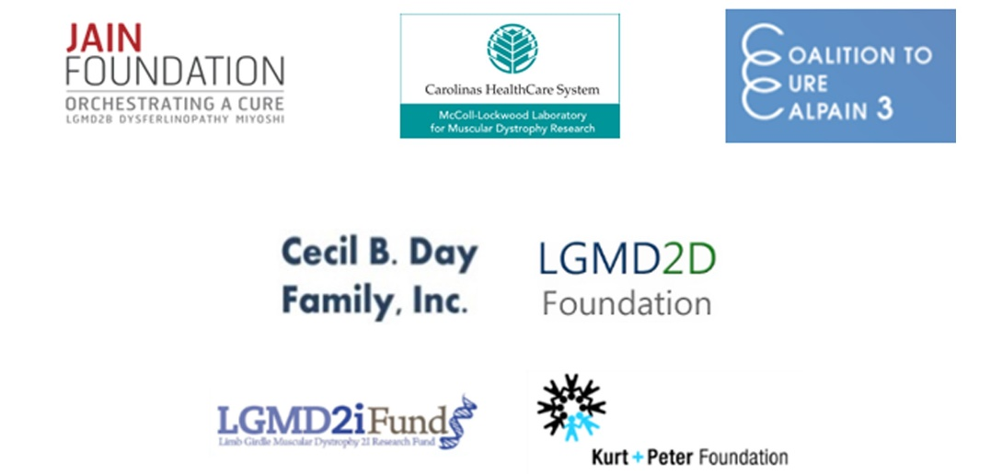**

The LGMD consortium is made up of [7 not-for profit organizations](http://lgmd-diagnosis.org/about-the-sponsors) that have family members with various types of limb-girdle muscular dystrophy (LGMD). These organizations have banded together to produce a free diagnostic program called [LGMD-diagnosis.org](http://www.lgmd-diagnosis.org/) in partnership with EGL. This program provides free genetic analysis for 35 genes known to be involved in LGMDs and other similar muscular dystrophies. The goal is that by working together they will increase the pace of diagnosis and the development of therapies.

EGL's [Neuromuscular Disorders Panel](http://geneticslab.emory.edu/tests/MNEU1) includes testing for nemaline myopathy, limb girdle muscular dystrophy, Emery-Dreifuss muscular dystrophy, congenital muscular dystrophy, Zellweger syndrome spectrum, and cardiomyopathies. Individual disorders included on this panel are myoadenylate deaminase deficiency, erythrocyte AMP deaminase deficiency, myofibrillar myopathy, Duchenne/Becker muscular dystrophy, congenital disorder of glycosylation type 1a, malignant hyperthermia susceptibility, myoclonus dystonia, Marinesco-Sjogren syndrome, and distal arthrogryposis.

For more information on muscular dystrophies [download our Neuromuscular Disorders informational brochure](http://geneticslab.emory.edu/documents/NeuromuscularDisorders.pdf).

For more information on genetic testing options for additional neurologic disorders, please download our eBook, [Genetic Testing for Neurologic Disorders: A Clinician's Guide.](http://info.geneticslab.emory.edu/a-clinicians-guide-to-neurologic-testing-at-egl)